Equatorial Plane
# Source: AI Source: Provided by: [Data Path: Persons Table -> ID Column: 1, Name_En Column: Motasem Essam] -> From: [ChatGPT] on [7/25/2026]
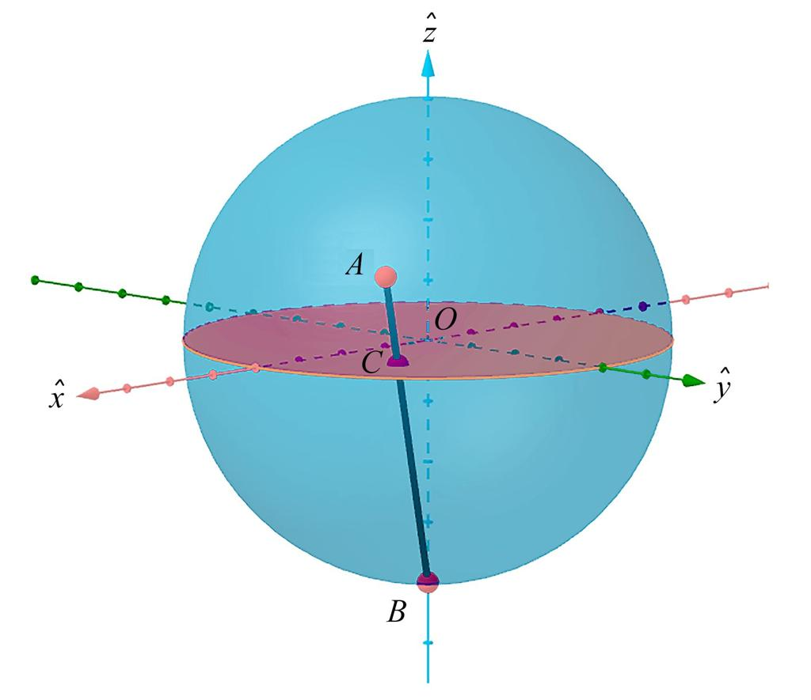
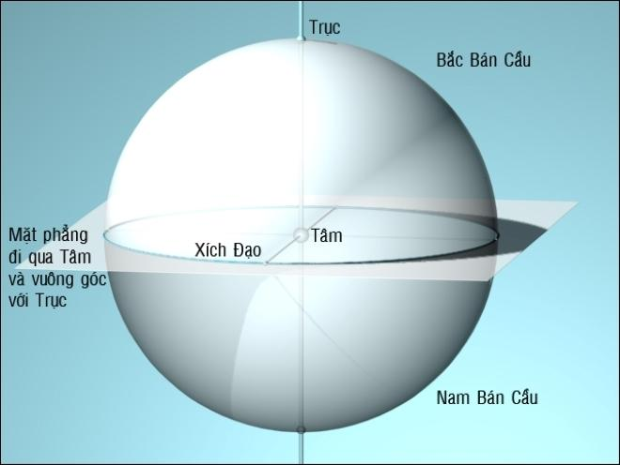
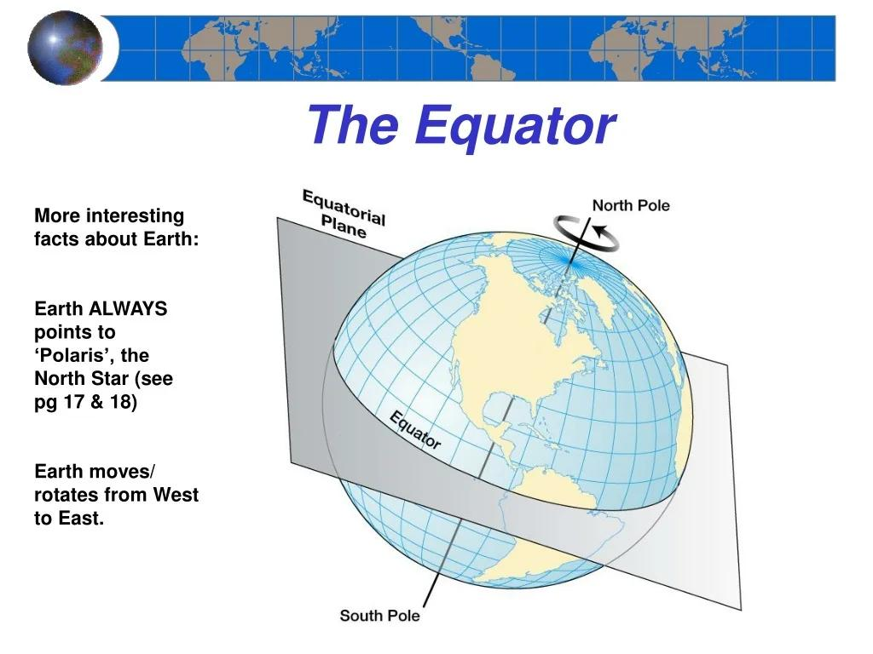

Definition
# Source: AI Source: Provided by: [Data Path: Persons Table -> ID Column: 1, Name_En Column: Motasem Essam] -> From: [ChatGPT] on [7/25/2026]
The equatorial plane is a plane that passes through the center of a sphere and is perpendicular to a chosen axis, usually its axis of rotation.
For Earth, the equatorial plane passes through Earth's center and is perpendicular to its rotational axis. It contains the Earth's Equator, which is the great circle formed where this plane intersects the spherical surface.
The equatorial plane extends infinitely in all directions within the plane; it is not limited to the circular region inside the sphere.

Simple Definition
# Source: AI Source: Provided by: [Data Path: Persons Table -> ID Column: 1, Name_En Column: Motasem Essam] -> From: [ChatGPT] on [7/25/2026]
The equatorial plane is an imaginary flat plane passing through the middle of a sphere, perpendicular to its axis.
It divides the sphere into two equal hemispheres: an upper half and a lower half relative to the chosen axis.

Geometric Representation
# Source: AI Source: Provided by: [Data Path: Persons Table -> ID Column: 1, Name_En Column: Motasem Essam] -> From: [ChatGPT] on [7/25/2026]
Consider a sphere centered at $O$, with radius $R$, and a vertical axis passing through its north and south poles.
The equatorial plane:
- Passes through the center $O$.
- Is perpendicular to the chosen axis.
- Intersects the sphere along its equatorial great circle.
- Divides the sphere into two equal hemispheres.
Important distinction:
- Equatorial plane: The infinite plane through the sphere's center.
- Equatorial great circle: The circular intersection between that plane and the sphere's surface.
- Equatorial disk: The filled circular region inside the sphere's cross-section at that plane.

Mathematical Representation
# Source: AI Source: Provided by: [Data Path: Persons Table -> ID Column: 1, Name_En Column: Motasem Essam] -> From: [ChatGPT] on [7/25/2026]
Suppose a sphere has its center at the origin:
$$O=\left(0,0,0\right)$$
and its rotational axis coincides with the $z$-axis.
The equation of the sphere is
$$x^{2}+y^{2}+z^{2}=R^{2}$$
The equatorial plane is described by
$$\boxed{z=0}$$
This plane is perpendicular to the $z$-axis and passes through the sphere's center.
Substituting $z=0$ into the sphere equation gives the equatorial great circle:
$$\boxed{x^{2}+y^{2}=R^{2}, z=0}$$
The corresponding equatorial disk is
$$\boxed{x^{2}+y^{2}≤R^{2}, z=0}$$

Key Characteristics
# Source: AI Source: Provided by: [Data Path: Persons Table -> ID Column: 1, Name_En Column: Motasem Essam] -> From: [ChatGPT] on [7/25/2026]
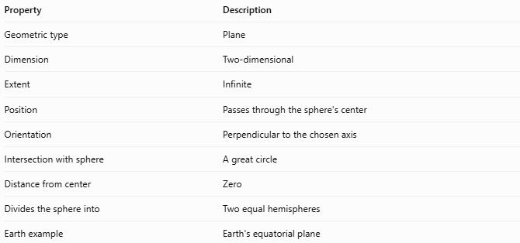
Property | Description
Geometric type | Plane
Dimension | Two-dimensional
Extent | Infinite
Position | Passes through the sphere's center
Orientation | Perpendicular to the chosen axis
Intersection with sphere | A great circle
Distance from center | Zero
Divides the sphere into | Two equal hemispheres
Earth example | Earth's equatorial plane

Worked Example
# Source: AI Source: Provided by: [Data Path: Persons Table -> ID Column: 1, Name_En Column: Motasem Essam] -> From: [ChatGPT] on [7/25/2026]
Problem: A sphere has a radius of $8\text{ cm}$ and is centered at the origin. Find the equation of its equatorial plane and the radius of the resulting circular cross-section.
Step 1 — Equation of the equatorial plane
If the sphere's axis is the $z$-axis, the equatorial plane is
$$\boxed{z=0}$$
Step 2 — Equation of the cross-section
The sphere's equation is
$$x^{2}+y^{2}+z^{2}=64$$
Setting $z=0$:
$$x^{2}+y^{2}=64$$
Step 3 — Find the cross-section radius
Comparing with the circle equation $x^{2}+y^{2}=r^{2}$:
$$r^{2}=64$$
$$\boxed{r=8\text{ cm}}$$
The equatorial cross-section is a great circle with the same radius as the sphere.

Equatorial Plane vs. Related Concepts
# Source: AI Source: Provided by: [Data Path: Persons Table -> ID Column: 1, Name_En Column: Motasem Essam] -> From: [ChatGPT] on [7/25/2026]
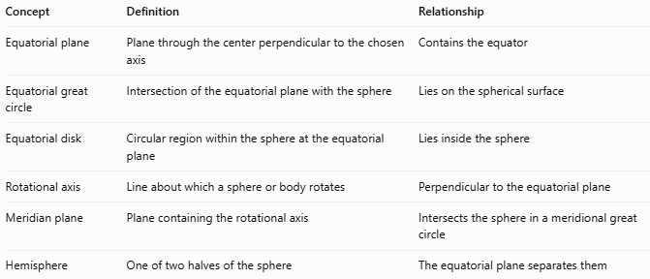
Concept | Definition | Relationship
Equatorial plane | Plane through the center perpendicular to the chosen axis | Contains the equator
Equatorial great circle | Intersection of the equatorial plane with the sphere | Lies on the spherical surface
Equatorial disk | Circular region within the sphere at the equatorial plane | Lies inside the sphere
Rotational axis | Line about which a sphere or body rotates | Perpendicular to the equatorial plane
Meridian plane | Plane containing the rotational axis | Intersects the sphere in a meridional great circle
Hemisphere | One of two halves of the sphere | The equatorial plane separates them

Applications
# Source: AI Source: Provided by: [Data Path: Persons Table -> ID Column: 1, Name_En Column: Motasem Essam] -> From: [ChatGPT] on [7/25/2026]
- Geography: Defining the reference plane for Earth's Equator and latitude.
- Astronomy: Establishing equatorial reference planes for planets and celestial bodies.
- Solid geometry: Studying spherical cross-sections and symmetry.
- Physics: Describing rotational motion and the orientation of spherical bodies.
- Computer graphics: Defining a horizontal reference plane for a sphere's coordinate system.

Key Points
# Source: AI Source: Provided by: [Data Path: Persons Table -> ID Column: 1, Name_En Column: Motasem Essam] -> From: [ChatGPT] on [7/25/2026]
- The equatorial plane passes through the sphere's center.
- It is perpendicular to the chosen axis.
- For a sphere centered at the origin with its axis along $z$, its equation is $z=0$.
- Its intersection with the sphere is an equatorial great circle.
- It divides the sphere into two equal hemispheres.
- Unlike the equatorial great circle, the plane extends infinitely beyond the sphere.

Conclusion
# Source: AI Source: Provided by: [Data Path: Persons Table -> ID Column: 1, Name_En Column: Motasem Essam] -> From: [ChatGPT] on [7/25/2026]
The equatorial plane is a fundamental reference plane in solid geometry. It passes through the center of a sphere and is perpendicular to its chosen axis. Its intersection with the sphere forms the equatorial great circle, and it separates the sphere into two equal hemispheres. The plane is especially useful in geography, astronomy, and three-dimensional coordinate systems.

